Updating the Fiscal Impact Measure

Sage Belz

October 3, 2019

**The Code**

The code to update the FIM is on the Hutchins Sharepoint site under Projects\Fiscal Impact\code. In order to update the FIM from your PC, ensure that you have the following software and R packages: (1) Haver package in R, proprietary to Haver (2) Rmarkdown package in R (3) some TeX compiling software, probably MikTeX. The code is structured as follows:

1. fim_datapull updates the quarterly data using the Haver API plugin in R, reads in the manually collected data from csv’s, and prepares the datasets for the FIM calculations. For a directory of the data Table 1 below.
   1. Some crucial data need to be updated manually. See section 2 below.
2. fim_projections performs the main calculations to translate the CBO budget and economic projections into forecasts of the components that are used to construct the FIM. This script sources fim_datapull. These calculations include a number of potentially confusing adjustments to the CBO projections. These should be well-documented in the code, but they include:
   1. Translating annual projections of taxes and transfers into a quarterly frequency
   2. Adjusting fiscal-year based projections of COLA-based transfers into smoothed calendar-year, quarterly forecasts
   3. Constructing an alternative path for personal taxes after year 2025 when the provisions expire (not necessary for near term projections, but we’re keeping the code so we don’t have to rewrite it later).
   4. Reattributing federal Medicaid spending that occurs at the state and local level to the federal government, so that these transfers appear in the federal component of the FIM.
3. fim_calculations performs all of the calculations for the FIM and writes data to the appropriate folders, named by the date of the projection. It sources fim_projections. The code calculates the contribution to real GDP growth from each headline (state, federal, taxes + transfers) and subcomponent of the FIM beyond what would have occurred if the component had been growing with real potential GDP. Read the document, “Deriving the fiscal impact measure” for a more thorough treatment of the FIM calculations. This code produces two key dataframes:
   1. fim, a df containing the fim calculations for the full series and all the subcomponents
   2. fim_interactive, a df that has been tailored to post on the website and use as the underlying data for the interactive.
4. fim_figures takes data from fim_calculations and draws static figures for reference and to go in the PDF’s on the website.
5. Fiscal-Impact produces the PDF that gets uploaded to the website.

Once the CBO data are up to date, one can simply run fim_figures with the option render = TRUE and produce the full suite of products necessary to update the website.

**Updating the CBO data**

There are three csv’s in the Fiscal Impact\data folder that need to be updated manually when new CBO projections are published. They should be updated by maintaining the existing variable names, formats, and date formats in the existing CSV’s and either replacing or appending new data where appropriate. The basic idea is that we want to take CBO projections and append them to the end of historical data series (of course, with adjustments) in a smooth manner. The code above assumes that the series will have consistent names in the historical and projected data. The three csv’s are:

1. cbo_econ_proj_quarterly.csv contains the CBO quarterly projections for GDP, inflation, and government consumption and investment. New data are published on a semiannual basis under the ‘**10-Year Economic Projections’** tab on [this page](https://www.cbo.gov/about/products/budget-economic-data#4). The variable names in the csv should be preserved and match the codenames for the series in the Haver database. To find the variables to update, match the names in the CSV with their description in Table 1 below, and then find the relevant variables in the CBO data. This gets updated on a **semiannual basis**.
2. cbo_econ_proj_annual.csv contains the CBO annual projections for GDP, inflation, and government consumption and investment. New data are published on a semiannual basis under the ‘**10-Year Economic Projections’** tab on [this page](https://www.cbo.gov/about/products/budget-economic-data#4). Ensure that you take projections for the *calendar year* rather than the *fiscal year*. Follow the same process as for the quarterly projections. This gets updated on a **semiannual basis**.
3. cbo_budget_nipas_proj_annual.csv contains CBO projections for annual (calendar year) federal tax and transfer items. CBO typically only projects these items in terms of the budget account (as opposed to the national accounts, which we need), but once per year they translate them into national accounts (NIPA) terms. We use this. The data can be found [here](https://www.cbo.gov/taxonomy/term/2/recurring-reports) (recurring reports) under ‘**Federal Receipts and Expenditures in the National Income and Product Accounts.’** Again, the variable names in the existing CSV match those of their Haver counterparts and should be preserved. This gets updated **once per year**.

Finally, in order to properly reattribute the Medicaid spending to federal, state and local entities, we need data on the FMAPs, or shares of state Medicaid spending that is paid for by the federal government. The csv to **update on an annual basis** is called nhe_fmap.csv. The data can be found here: [CMS.gov](https://www.cms.gov/Research-Statistics-Data-and-Systems/Statistics-Trends-and-Reports/NationalHealthExpendData/NationalHealthAccountsHistorical.html) National Health Expenditure Data > Historical > NHE by type of service and source of funds.csv. The latest year of data should come from the line items for total federal spending on Medicaid and CHIP, total state and local spending on Medicaid and CHIP. Fhsare is the share of total spending on Medicaid and CHIP that is federal.

**Table 1: Metadata for FIM data**

*Note: In general, ‘h’ denotes a real variable as opposed to nominal, ‘g’ refers to government expenditure items, ‘f’ refers to federal government expenditure items, and ‘s’ to state and local government expenditures. Strikethrough means we don’t use it in the calculations.*

|  |  |  |  |
| --- | --- | --- | --- |
| Variable Name / Haver Code | Description | BEA Table | Raw Source for Historical Data |
| gdp | Gross Domestic Product (SAAR, Bil.$) | 1.1.6 | BEA, NIPAS |
| c | Personal Consumption Expenditures (SAAR, Bil.$) | 1.1.6 | BEA, NIPAS |
| ch | Real Personal Consumption Expenditures (SAAR, Bil.Chn.2012.$) | 1.1.5 | BEA, NIPAS |
| gdph | Real Gross Domestic Product (SAAR, Bil.Chn.2012$) | 1.1.5 | BEA, NIPAS |
| jc | Personal Consumption Expenditures: Chain Price Index (SA, 2012=100) | 1.1.4 | BEA, NIPAS |
| jgdp | Gross Domestic Product: Chain Price Index (SA, 2012=100) | 1.1.4 | BEA, NIPAS |
| jgf | Federal Govt Consumption & Gross Investment: Chn Price Index(SA, 2012=100) | 1.1.4 | BEA, NIPAS |
| jgs | State & Local Govt Consumption/Gross Investment: Chn Price Index(SA, 2012=100) | 1.1.4 | BEA, NIPAS |
| yptmr | Government Social Benefit Payments to Persons: Medicare (SAAR, Bil.$) | 2.1 | BEA, NIPAS |
| yptmd | Government Social Benefit Payments to Persons: Medicaid (SAAR, Bil.$) | 2.1 | BEA, NIPAS |
| yptu | Govt Transf to Persons: Unemployment Insurance Benefits (SAAR, Bil.$) | 2.1 | BEA, NIPAS |
| gtfp | Government Social Benefit Payments to Persons (SAAR, Bil.$) | 3.1 | BEA, NIPAS |
| ypog | Personal Current Transfer Payments to Government (SAAR, Bil.$) | 2.1 | BEA, NIPAS |
| yptx | Personal Current Taxes (SAAR, Bil.$) | 3.1 | BEA, NIPAS |
| ytpi | Government Tax Receipts on Production & Imports (SAAR, Bil.$) | 3.1 | BEA, NIPAS |
| yctlg | Government Tax Receipts on Corporate Income (SAAR, Bil.$) | 3.1 | BEA, NIPAS |
| g | Government Consumption Expenditures & Gross Investment (SAAR, Bil.$) | 1.1.5 | BEA, NIPAS |
| ~~gfrcf~~ | ~~Federal Govt Tax Rcpts on Corporate Income: Federal Reserve Banks (SAAR, Bil.$)~~ |  | ~~BEA, NIPAS~~ |
| grcsi | Contributions for Government Social Insurance (SAAR, Bil.$) |  | BEA, NIPAS |
| ~~dc~~ | ~~Personal Consumption Expenditures: Implicit Price Deflator (SA, 2012=100)~~ | ~~3.1~~ | ~~BEA, NIPAS~~ |
| gf | Federal Government Consumption & Gross Investment (SAAR, Bil.$) | 1.1.5 | BEA, NIPAS |
| gs | State & Local Government Consumption & Gross Investment (SAAR, Bil.$) | 1.1.5 | BEA, NIPAS |
| gfh | Real Federal Government Consumption & Gross Investment (SAAR, Bil.Chn.2012$) | 1.1.6 | BEA, NIPAS |
| gsh | Real State & Local Govt Consumption & Gross Investment (SAAR, Bil.Chn.2012$) | 1.1.6 | BEA, NIPAS |
| gfrpt | Federal Government Personal Current Tax Receipts (SAAR, Bil.$) | 3.2 | BEA, NIPAS |
| gfrpri | Federal Government Tax Receipts on Production & Imports (SAAR, Bil.$) | 3.2 | BEA, NIPAS |
| gfrcp | Federal Government Tax Receipts on Corporate Income (SAAR, Bil.$) | 3.2 | BEA, NIPAS |
| gfrs | Contributions for Federal Government Social Insurance (SAAR, Bil.$) | 3.2 | BEA, NIPAS |
| gftfp | Federal Government Social Benefit Payments to Persons (SAAR, Bil.$) | 3.2 | BEA, NIPAS |
| gfeg | Federal Grants-in-Aid to State & Local Governments (SAAR, Bil.$) | 3.2 | BEA, NIPAS |
| gfeghhx | Federal grants-in-aid to state and local governments: Health and Hospitals (SAAR, Mil.$) | 3.24U | BEA, NIPAS U |
| gfeghdx | Federal grants-in-aid to state and local governments: Medicaid (SAAR, Mil.$) | 3.24U | BEA, NIPAS U |
| gfiegx | Federal capital grants to state and local governments (SAAR, Mil.$) | 5.11U | BEA, NIPAS U |
| gsrpt | State & Local Government Personal Current Tax Receipts (SAAR, Bil.$) | 3.3 | BEA, NIPAS |
| gsrpri | State & Local Government Tax Receipts on Production & Imports (SAAR, Bil.$) | 3.3 | BEA, NIPAS |
| gsrcp | State & Local Government Tax Receipts on Corporate Income (SAAR, Bil.$) | 3.3 | BEA, NIPAS |
| gsrs | Contributions for State & Local Government Social Insurance (SAAR, Bil.$) | 3.3 | BEA, NIPAS |
| gstfp | State & Local Government Social Benefit Payments to Persons (SAAR, Bil.$) | 3.3 | BEA, NIPAS |
| ~~ptgh~~ | ~~Government Consumption & Investment: Contrib to Real GDP % Change (SAAR, %Pt)~~ |  | ~~BEA, NIPAS~~ |
| ~~ptgsh~~ | ~~State & Local Govt Consumption/Investment: Contrib to Real GDP % Chg (SAAR, %Pt)~~ |  | ~~BEA, NIPAS~~ |
| ~~ptgfh~~ | ~~Federal Govt Consumption & Investment: Contrib to Real GDP % Change (SAAR, %Pt)~~ |  | ~~BEA, NIPAS~~ |
| pcw | CPI-W: All Items (SA, 1982-84=100) |  | BLS |
| gdppothq | Real Potential Gross Domestic Product [CBO] (SAAR, Bil.Chn.2012$) |  | CBO |
| gdppotq | Potential Gross Domestic Product [CBO] (SAAR, Bil.$) |  | CBO |
| recessq | Quarterly NBER Recession/Expansion: Recession Shading |  | NBER |

**The Website Interactive**

Beyond updating the text on the website, we also need to update the downloadable PDF, downloadable data, and the backend data for the interactive itself. The interactive on the website is maintained by the comms team but we should be able to update the data ourselves through Wordpress. As of this writing there are technical issues with this so I won’t describe this part of the process.

Updating the website involves simply updating the Wordpress page and uploading the fim-interactive CSV and the Fiscal-Impact PDF as downloadables.

1. Update the landing page. Go to Content > Interactives > Hutchins Center Fiscal Impact Measure. It looks like this:

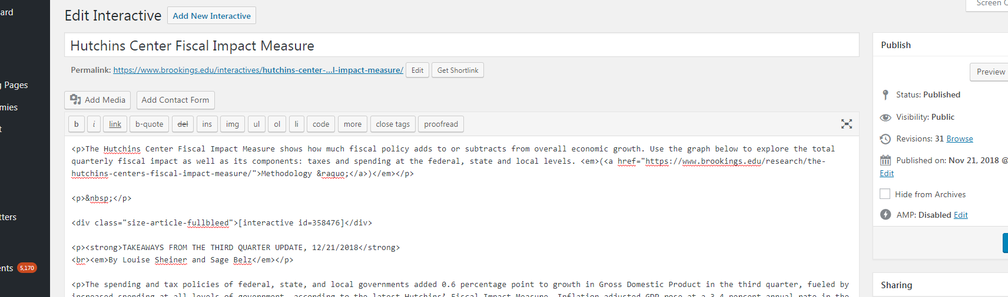

Update the text, publishing date and any other relevant entries. Upload new files for the Download: Print version (PDF) and Download: Raw data (CSV) entries.

1. Update the data for the interactive figure. Go to Media > Search “fim-interactive”. Click on the file, then go to Edit more details > Replace media file > Choose file. Select and upload the most recent fim-interactive.csv from this month’s folder. Close out the page.

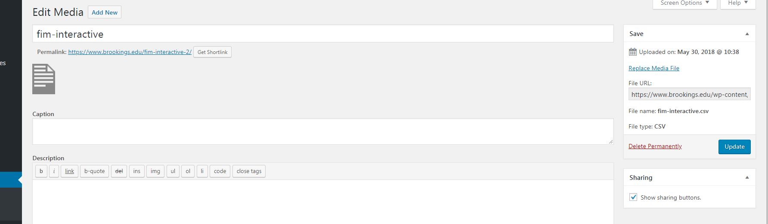

1. Go to the FIM webpage, hard refresh and make sure everything looks right. In particular, ensure that the interactive is updated and that all the dates on the page are correct.